BankLink Toolkit for New Zealand
Table of Contents
1: Welcome to BankLink! 1
2: What is BankLink? 3
BankLink for your practice 4
BankLink for your clients 5
BankLink privacy statement 6
3: What are the Benefits? 9
Quotes from BankLink practices on the benefits... 12
4: What are the Costs? 15
How practices charge their clients for BankLink 17
5: Getting started with BankLink 19
The Client and Technology Checklists 20
The client checklist 21
The technology checklist 23
More help and support 25
6: Which clients are suitable for BankLink? 27
Checklist of who to put onto BankLink: 28
Quotes from BankLink practices on suitable clients … 29
7: Ways of using BankLink 31
The BankLink Client Tools 33
Analysis coding 37
8: Signing your clients up 41
Ways to approach your clients 42
Sample Letters 43
Sample BankLink article for practice newsletters 51
Sample PowerPoint presentation for a client seminar 52
Sample advertisement 53
Sample Third Party Authority Form 54
Frequently Asked Questions 55
9: Reports and graphs 59
Example Financial Report Package 60
Graph – One Page Summary 61
10: Administration 63
Add Account Form 64
Financial Institution Request Form 65
BankLink Secure Client Order Form 66
Software Kit Order Form 67
Marketing Materials Order Form 68
Glossary of BankLink terms 69
11: Index 71

Welcome to BankLink!

The BankLink Toolkit
The BankLink Toolkit helps you to implement the BankLink service in your practice.
Developed with assistance from accounting practices like yours, the Toolkit is designed to help you identify suitable BankLink clients, sell the BankLink idea to them, guide you through signing them onto the service, and to provide on-going support so that you maintain BankLink for maximum profitability.
All sections of the Toolkit are available as Microsoft Word documents for you to adapt to your practice requirements, along with several Microsoft PowerPoint presentations to help you explain BankLink to clients and staff. All the documents and presentations are available on your BankLink Practice CD.
The BankLink Toolkit is your central resource for:
- Information about the BankLink service, and how it makes your practice more effective
- What BankLink costs you and suggestions on how you can charge your clients for it
- Guidance on signing your clients up to the BankLink service
- Sample documents for you to adapt to suit your practice:
- Timetable for client set-up
- Letters to send to clients
- Client seminar PowerPoint presentation
- Advertisement
- Article for practice newsletter
All the Toolkit files are on the BankLink Practice CD, which contains all the software you need to use BankLink as well as all the support files for you to view, edit and print as you require.
Please contact BankLink Sales on 0800 226 554 with any questions regarding the material in the Toolkit.

What’s in this Toolkit?

What is BankLink?
A brief overview of the BankLink service from a practice and then a client perspective. The diagram showing how BankLink operates may be useful in explaining BankLink to clients.

What are the benefits?
This section contains feedback from practices about how they find BankLink benefits both their practice and their clients. You can use it as a guide to ensure that your practice receives all the benefits of using the BankLink service.

What are the costs?
This section sets out the BankLink charges and lists several ways that practices pass them on to their clients.

Getting started with BankLink
Read this section to understand what you need to do to get up and running with the BankLink service, and to find out about the other help and support material available to you.

Which clients are suitable for BankLink?
Most clients are suitable for the BankLink service, so this section looks at some real-life examples.

Ways of using BankLink
This section covers the BankLink client tools. There are pointers on marketing each tool and a timetable to give you an idea of how long the process takes.

Signing your clients up
In this section you'll find all the back-up material that you need to get started. There are sample letters, an advertisement and a newsletter article, as well as answers to questions practices tell us are most frequently asked by clients. These documents are all on the BankLink Practice CD for you to customise for presentations to your clients.

Value added reports and graphs
As well as GST Returns, the reports and graphs you can produce in BankLink Practice mean great added value to the service you offer clients. This section covers the variety of reports and graphs available and includes some examples.

Administration
This section deals with the administration of BankLink within the practice, as well as a glossary of the main terms used throughout BankLink Practice, and an index to the Toolkit.

What now?
If you're already familiar with the BankLink service, you can skip to Getting started with BankLink to understand the tasks you need to carry out. Otherwise, start with What is BankLink?

What is BankLink?
This section gives a brief overview of what the BankLink service is, how it operates and who uses it from a practice and then client perspective.
It provides background information on the BankLink service to decision makers who are new to BankLink.
The client-level description of the BankLink service and the diagram showing how it works may be useful when explaining BankLink to clients.
The BankLink Privacy Statement is also included.
Answers to many frequently asked questions clients may have about the BankLink service can be found in the Implementing BankLink section of this Toolkit.
Use the following How BankLink works diagram to clearly show the BankLink process to your client.
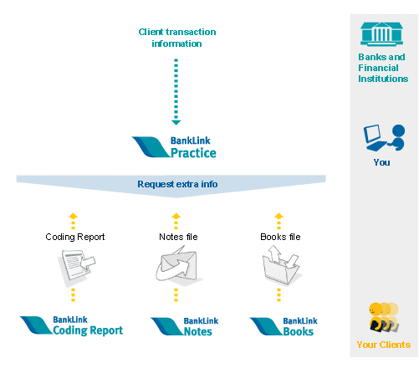

BankLink for your practice
Over 3,000 accountancy practices in New Zealand and Australia use BankLink. The company is New Zealand owned and operated, and was founded in 1986.
BankLink collects data from financial institutions and every month (or week) sends you secure electronic copies of your clients’ statements via the Internet. Data entry is eliminated and data accuracy is improved.
All major banks supply data through BankLink and there is increasing access to other financial institutions with over 100 banks, building societies, credit cards, credit unions and rural suppliers supplying data to BankLink in Australia and New Zealand. For the latest list of which financial institutions provide data to BankLink go to www.banklink.co.nz.
The BankLink service saves both time and money. Our proven, time-saving tool for compliance accounting, BankLink Practice can automate your coding and allows you to manage and report on your clients’ transactions.
BankLink Practice integrates with your practice accounting systems to enable the transfer of data to your general ledger.
BankLink provides several tools for communicating with your clients, depending on their familiarity with computers and accounting principles. See the Ways of Using BankLink section for descriptions of each of the client tools.

BankLink for your clients
Accountants use the BankLink service to complete their clients’ book work efficiently and accurately. It works by collecting a secure, electronic copy of your bank statement data (once you have given permission of course) from your financial institution, and delivering this to your accountant.
It means that a copy of all your financial data comes directly to the practice. No more storing up cheque book stubs, misplacing bank statements, or providing your reconciliation on diskette. Using BankLink saves you time that is better spent on running your business.
From this information, practices can easily code the transactions or quickly identify where they need more information from you. They can also provide quick, accurate information for GST returns.
BankLink’s track record is great (it has been in operation since 1986) and the BankLink service is used by over 3,000 accountancy practices throughout Australia and New Zealand.
BankLink receives information from over 100 financial institutions in Australia and New Zealand for more than 200,000 bank accounts. Check with your accountant to see if a copy of your statement information can be provided by BankLink.
As the BankLink service allows accountants to work with clients' accounts on a regular basis, they can keep track of business performance and provide improved business information when it's needed.

BankLink privacy statement

About BankLink
BankLink Limited
PO Box 56-354, Dominion Road, Auckland 1446
Tel: 0800 226 554
Fax: +64 9 377 8744

Your personal information
BankLink believe an individual’s right to keep their personal information private is highly important. We have systems and procedures in place to protect your privacy whenever we collect, store, and use your information in order to provide the BankLink service.
We respect your rights under the 1993 Privacy Act which sets out principles relating to the protection of your personal information.
This privacy statement contains our policies in relation to the management of your personal information.
Personal information is information or an opinion about an individual whose identity is apparent or can reasonably be ascertained from the information. This includes information which is written, oral or electronic.
If you require more details about the personal information we hold, and the purposes for which, and way in which, we collect, hold, use, and disclose that information, you should contact us.

When, why and how we collect your personal information
We will collect your personal information directly from your bank, building society, credit union or other service provider and any other source you have authorised us to collect information from.
We will only collect personal information in order to provide the BankLink service. The information we collect will be your name, account number, transactional records and the other details which appear on the paper statement provided by your bank, building society, credit union or other service provider.
We will obtain your written consent to collect your information. By signing the BankLink Third Party Authority Form, you are giving your express consent for us to collect this information.
We will not collect any sensitive information which includes information about your race, religious or political affiliations or information relating to your health.

How we use your information
We will only use your information:
- to provide (and maintain) the BankLink service, which is to provide the software infrastructure and linkages to enable your statements and transactional records to be received by your accountant or financial adviser, or
- to fulfil our legal requirements (for example, disclosure to law enforcement agencies or the courts).

Who will use your information
We will supply your statement information to your accountant or financial advisor in order to provide the BankLink service.
Apart from using your information to provide the BankLink service and fulfilling our legal obligations, we will not disclose your information to any other company or person.
We will not sell or trade your information.

Your information is secure
We will use up-to-date techniques and processes to ensure that your information is kept secure from misuse, loss and un-authorised access, modification or disclosure and is kept confidential.
In protecting your information and keeping it secure, we will meet the current industry standards of the banks, building societies, credit unions and other statement providers who supply us with your statement information.
We maintain physical security, such as locks and security systems, over our paper and electronic data stores and premises and only allow access by people authorised by us either to provide the service or to check and maintain its operation.
We will not retain any of your information for any longer than it is required by us to provide the BankLink service, except to fulfil our legal obligations.

You can request access to your information
You can request access to the personal information we hold about you by contacting us on 0800 226 554. This service is free unless the information you request requires significant research or preparation time. Before we act upon requests of this nature, we will tell you how much this service will cost.

How to make a complaint
BankLink is committed to the protection of your privacy. Our policies, processes and systems have been developed with this intent. However, if you have a privacy complaint please contact us on 0800 226 554.
Our Privacy Officer will take responsibility for the complaint. The objective of our Privacy Officer is to respond to any complaint within five working days.

What are the Benefits?
Here are just some of the ways accountants tell us the BankLink service benefits their practices. Use this as a guide to make sure that your practice is getting all the advantages of BankLink it can.

100% recovery of data entry time
- Receive financial statement information faster
- Download all financial statement data in one easy, secure process
- Eliminate manual data entry
- End time wasted chasing clients for statement data or waiting for replacement statements

Improved data quality and coding speed
- There are no more keying errors and missing data
- Eliminate repetitive tasks using BankLink Practice’s automated coding tools
- Use BankLink Practice’s sorting and column configuration features to speed coding

Automated processes
- Produce bank reconciliations automatically – no more manual reconciliations
- Create and send out BankLink Coding Reports, BankLink Notes files and BankLink Books files to all clients in one process

Faster client response
- Prompt your clients for information with regular Coding Reports or BankLink Notes files and spend less time reminding them to provide their book work

Use the BankLink service to improve your systems
- Convert clients who prepare time-consuming manual cashbooks to BankLink Books
- Work with the data on a more frequent basis, smoothing workflow peaks
- Receiving data regularly means more regular contact with clients, improving the accuracy of information received because clients don't have to remember too far back in time
- Manage your clients and staff, monitor workflow and the status of client files using BankLink Practice's Client Manager and Client Status Report
- Cater for all clients regardless of their bookkeeping ability. Either,
- supply BankLink Books to capable clients to use as a basic cashbook or
- automatically produce a BankLink Notes file that can be e-mailed to clients or
- automatically produce a Coding Report that can be e-mailed, faxed or posted to clients
With the second and third options you can let your client note details of each transaction or actually code – you choose the level
- BankLink Practice interfaces to all main accounting systems. You can also interface to some of your clients accounting software packages
- For GST audits you can quickly and easily identify where transactions occur and their GST rating
- Staff can use BankLink Books when they're not in the office, either out at a client site, a satellite office, or from a remote laptop
- Allocate client files to individual staff members to manage and use security to protect sensitive client files

Add value to the service you provide clients
- Provide monthly management reports for clients at the click of a button
- Improve the relationship with your clients by producing useful and accurate information on a regular basis for discussion with them
- Reduce time spent on compliance work and free-up valuable time to spend on worthwhile business development advice for your clients
- Complete GST preparation effectively cost free to the practice as the GST Return is completed as a by-product of coding

Convenience for Clients
- Clients save hours of time that would have been spent doing the books
- Remote clients provide information, while retaining their invoices and bank data
- Email information about transactions (BankLink Notes and BankLink Coding Report ) to and from the client
- The free licence with the software means you can provide a solution to small business clients’ accounting software needs and eliminate the use of inferior accounting software packages
- Capable clients code part or all of their transactions, relying on your practice to complete processing
- No more GST ‘panic’. Financial statement data is supplied to the practice on the first working day of the month, or even weekly, so that more information is at hand to complete the GST requirements without bothering the client for missing statements
- BankLink provides your practice with regular data so you can keep track of your clients' business performance, provide them with improved business information and react quickly to their needs
- Keep track of business at a glance with BankLink Practice’s management reports and graphs

BankLink’s Service
- Over 3,000 practices use the BankLink service
- BankLink continuously invests in enhancing its product based on feedback from these practices
- There is no large initial outlay to get up and running with BankLink
- BankLink has over 20 years of experience and programming to support the product
- BankLink has a proven reputation for excellent support and service
- BankLink support and telephone training is free to all practice users
- All BankLink marketing material is free - this includes sample client letters, PowerPoint presentations, newsletter articles etc.
- Upgrading your BankLink Practice, Books and Notes software is free, and can be done from within the software, or via the Internet
- BankLink gives you access to data from over 100 financial institutions

The diagrams below show the flow of data through the practice, before and after BankLink...
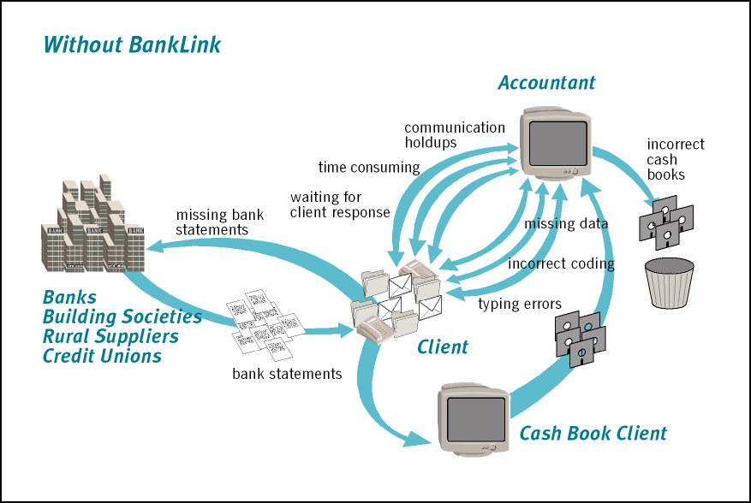
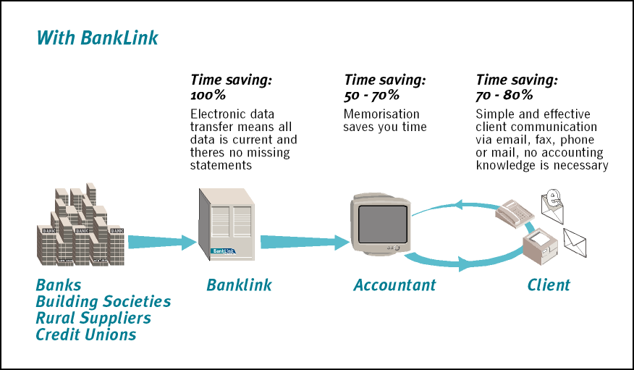

Quotes from BankLink practices on the benefits...

BankLink saves time:
"BankLink is a fantastic tool for saving time on data processing. I can't imagine living without it. I don't believe that anyone could run an efficient compliance accounting practice in New Zealand today without it."
Campbell Tyson, Pukekohe
"A case study we use to "sell" BankLink to our clients is based on one of the first clients we put on BankLink. What used to be four hours of processing was reduced to 3/4 of an hour - a huge saving!"
Julie Stevenson, STRATAGEM, New Plymouth
"Being able to access Fonterra statement information saves an enormous amount of time for us. Typically we can get over 95% of our clients' entries automatically coded when we download the BankLink information. This means we get the information faster and we get improved data quality by eliminating manual re-keying. For us to be able to do GST returns for our clients in a hurry, BankLink is crucial. The memorisation feature is brilliant - it means we can get our rural clients' GST returns done much faster."
Bruce Crowther, Finn & Partners, Te Awamutu
"With nearly 200 clients receiving Fonterra statements, BankLink saves us hours of coding. Having the statement information reproduced in the ledger saves a lot of time. Using BankLink is ideal for enabling us to easily produce an analysis of expenditure on a regular basis or whenever the client requires it."
Grant Calvert, Shannon Wrigley & Co, Cambridge
"The major benefit is timeliness - the data is delivered at the right time and is very cost effective. It is a pretty powerful processing tool streamlining our entire workload. BankLink enables us to deliver to each client a timely cash flow report generated in our General Ledger, which has to be more beneficial for business decisions."
Graham Brown & Co Limited, Putaruru

BankLink improves practice systems:
"Normally you would have a bottleneck during the last two weeks of the month, but BankLink allows you to get GST out of the way before the 20th."
Jason Prisk, Grant Thornton (Whangarei) Ltd, Whangarei

BankLink adds value to the service you provide clients:
"BankLink has many advantages. It allows us to handle client information much faster, more tidily and more accurately. It's really user friendly and all the client information we are working with is up-to-date rather than historical."
Vera Kramer, West Yates Limited, Nelson
"Our clients love BankLink. It has revolutionised our client communications. We now give them meaningful information monthly (rather than just once a year - 2 to 3 months after balance date) and as they get a regular monthly account rather than a huge one - they know exactly what they owe us - they love that too!"
Mark McMullan, Martin Wakefield, Timaru
"At the end of the day…[BankLink] allows you to add value to the service you provide your clients. It lets you spread your workload more evenly throughout the year, and it forces the clients to look at their business on a more regular basis. It's a win-win situation for both the firm and our clients."
Hamish McDonald, KPMG Hamilton, Hamilton

BankLink benefits clients:
"Our Clients love the fact they don't have to keep cashbooks any more and that they can print relevant reports easily. We have trained several of our larger clients to use BankLink offsite and they have all found it very easy to learn. We also have numerous other clients benefiting from the use of BNotes. They love being able to code electronically - no more waiting for the coding report in the mail, and the use of the Notes field means both parties can deal with queries as they arise."
Iles & Campbell Ltd, Taupo

BankLink Service:
"Before we committed to BankLink we spent time evaluating the product to ensure that it was able to meet our needs. We then committed to it wholeheartedly. We have found BankLink to be outstanding in listening to us about refinements to the product and in their ongoing commitment to customer support."
Julie Stevenson, STRATAGEM, New Plymouth
"We told BankLink that we needed a change. They looked at it, talked to other committed users, then developed it and tested it with us, before releasing it. They are great at listening to their clients."
Vera Kramer, West Yates Limited, Nelson
"BankLink's customer service is exemplary. They are working with us to refine the administrative requirements of managing such a large pool of accounts and accounting management groups. Not so many software suppliers are so obliging. Everyone we have dealt with at BankLink is really professional in their customer support delivery, they have great follow-up and always listen to our requests."
Carey Goodwin, Graham Brown & Co Limited, Putaruru

What are the Costs?
How you decide to pass on the cost of BankLink is up to you. This section explains how BankLink charges the practice for the BankLink service and then details several case studies of ways practices charge their clients.

What BankLink charges the practice
All prices quoted are GST exclusive

The average cost of an account is less than $5 per month
Based on an average number of 50 transactions per month:
- Cost of 50 transactions 4.3¢ | $2.15
- Account charge per month | $2.00
- Average cost per account | $4.15
This example assumes that the practice has over 20 accounts on the BankLink service.
There is no initial charge for the software or any extra charge for the ongoing software upgrades. The practice pays a fixed monthly fee, called the Monthly Subscription to BankLink, which includes:
- The multi-user BankLink Practice software, BankLink Books and BankLink Notes which you are entitled to load at client sites
- The BankLink Toolkit
- All software upgrades
- Data download to the practice via BankLink Secure
- BankLink telephone support to the practice
- BankLink on-screen guide, information sheets and all other documentation
- BankLink marketing material provided to the practice

Two levels of BankLink charges

BankLink Charges (20 Accounts or Fewer)
- Monthly subscription to BankLink (per practice per month) | $69.00
The BankLink delivery charges are as follows:
- Monthly account charge (per bank account per month) | $4.50
- Banking transactions processed (per transaction) | 4.3¢
- Account load charge (per bank account established)* | $15.00
* This once only fee covers the cost of loading the account with the Financial Institution.

BankLink Charges (21 Accounts or More)
- Monthly subscription to BankLink (per practice per month) | $119.00
The BankLink delivery charges are as follows:
- Monthly account charge (per bank account per month) | $2.00
- Banking transactions processed (per transaction) | 4.3¢
- Account load charge (per bank account established)* | $15.00
* This once only fee covers the cost of loading the account with the Financial Institution.

The Charge Plans
If the practice has fewer than 20 accounts it is an advantage to pay a $69.00 practice fee and $4.50 per account. This keeps the BankLink charges to a minimum while a new practice builds their user base.
The total charge for a practice with 20 accounts is the same on either charge plan. Although the practice fee has increased by $50.00 the charge per account has been reduced by $2.50.
When the practice loads their 21st account BankLink automatically alters the charge plan to the $119.00/$2.00 combination. All subsequent accounts loaded will be charged at $2.00; this benefits all practices with more than 20 accounts.

BankLink Books users
BankLink offers the practice an option by which bank transaction data is delivered directly to their clients via the Internet delivery service, BankLink Secure.
Normal BankLink charges apply plus an additional monthly charge to the practice of $7.80 per client file.

Weekly Data
Weekly data is available from ANZ, ASB, BNZ, BNZ credit cards, HSBC, Macquarie (New Zealand), National Bank of New Zealand, Taranaki Savings Bank and Westpac.

How practices charge their clients for BankLink
The way you charge your clients for the BankLink service is entirely at your practice's discretion. However, we are often asked for examples of how other practices charge. The following case studies are based on real-life examples.
- Bundled Services
Practice A uses BankLink Practice to provide a range of services to its clients, including completion of GST returns and bi-monthly financial reports, using the graphs and reports from BankLink. The clients pay a fixed annual fee that includes telephone queries and on-going general advice. The annual fee, often replaced by monthly or bi-monthly fees, varies on the level of work carried out for the client. BankLink charges are absorbed by the practice.
The financial advantages of this method for the practice are the improvement in cash flow and the opportunity to provide more ‘value added services’ for their clients. From the clients’ perspective, the advantage of being able to budget for the year's accounting fees and having no ‘surprises’ at the end of the year are reported as being important.
- Percentage increase
Practice B charges clients on an hourly basis, but codes all work where BankLink Practice is used with a percentage increase. This is calculated to allow for the drop in number of hours worked and to ensure there is not a corresponding drop in fees. The fees for the BankLink service are absorbed by the practice but these are more than compensated for by the drop in hours worked.
- No change
Practice C charges clients on an hourly basis and absorbs the BankLink fees. The rationale for this is that hours saved more than compensate for the charges paid to BankLink.
- Disbursements
Practice D disburses all BankLink charges to its clients. Its purpose in charging on this basis is that it prefers the transparency of any costs incurred being passed directly on to the client.

Here’s what some practices say about charging clients:
"We set out to achieve consistency in the types of reports we were working with. This has allowed us to develop fixed price agreements with our clients that are cost effective for them and profitable for us - mutually beneficial. BankLink is one of our core solutions."
Julie Stevenson, STRATAGEM, New Plymouth
"We have a fixed rate price regime now with our clients for compliance work. The efficiencies we achieve with BankLink, and its consistent pricing, mean we make a fair profit and the clients know what they are up for - it's a win-win. Therefore we make it mandatory for our new clients to be BankLink clients"
Nick Grant, Atrium Chartered Accountants, Waipukurau

Getting started with BankLink

Introduction
Implementing BankLink is a straightforward process, during which you will be assisted by the BankLink Implementation team. To fast track the implementation phase your practice can take advantage of the BankLink Implementation Plan.
The BankLink Implementation Plan follows the Implementation Timeline below to get the BankLink service operating in your practice as soon as possible.
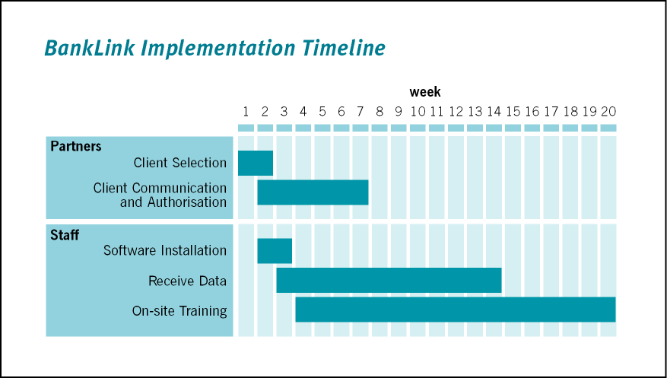
The steps involved are set out in checklists which relate to the Implementation Timeline.

The Client and Technology Checklists
To get BankLink up and running in your practice the steps you need to carry out two types of tasks:
- Client-oriented, and
- Technology-oriented
These are summarised in the checklists below and detailed on the following pages.
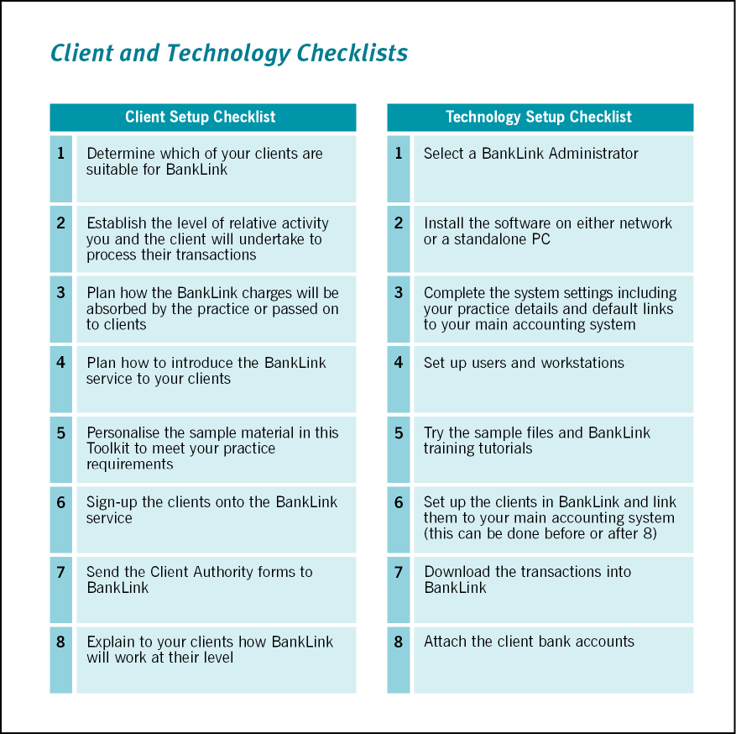

The client checklist
You need to complete the tasks on this checklist to start receiving your clients' data through the BankLink service. If you sign up for the BankLink Implementation Plan we will contact you to explain and discuss these activities, relating them directly to your practice (Contact your Regional Manager for more information).
 | Task | Done?
1. | Review your clients and decide which are suitable for BankLink  Read the What is BankLink?, What are the Benefits?, and Which clients are suitable? sections for background information to help determine which of your clients will benefit from the BankLink service, and to establish the type of client they are.
2. | Determine the levels of relative activity you and each client will undertake to process their transactions  Review the Ways of Using BankLink section to help you plan how each client will use the BankLink service.  BankLink allows you to serve your clients differently depending on their level of accounting experience, computer knowledge and reporting requirements. These factors determine which client tool you provide to your client to process their transactions.
3. | Plan how the BankLink charges will be absorbed by the practice or passed on to clients  Review the What are the Costs? section which sets out the BankLink charges along with examples of how practices these on. Also review the Reports and Graphs section to see which additional services you could be providing to your clients. You can then decide how (if at all) to pass BankLink charges on to your client.
4. | Plan how to introduce the BankLink service to your clients  With the help of the BankLink marketing information in the Signing your clients up section, decide how you will approach your clients to bring them onto BankLink using a mix of phone calls, mail-out, personal visits and presentations.
5. | Adapt the sample material in this Toolkit to meet your practice requirements  Start with the electronic copies of the sample letters provided on the BankLink Practice CD, personalise the material, and print it on your own letterhead.
6. | Sign the clients up to the BankLink service  Use the supplied Third Party Authority forms to get your clients signed up. You can call or email BankLink Client Services for more Authority Forms when you run out.
7. | Send the Third Party Authority Forms to BankLink  Don’t leave it too late! We can only start accumulating transactions to send to you once we have received the Third Party Authority Form and had it approved by the financial institution. The time taken to do this varies, but averages 5 working days. In addition, if the institution is not satisfied with the information on the form, we have to return it to you and the process starts again.  For example, if you require data from the 1st of June, we recommend you send the form to us by mid-May – this means that you have to start talking to your clients some time before then!  If you require data from the 1st of April, we recommend you send the form to us by the beginning of March – the new financial year is a busy time both for us and the financial institutions.  If you require weekly data (see the list of Financial Institutions on the BankLink website to find out which institutions supply data weekly) please make sure that you write this clearly on the Third Party Authority Form.  Don’t store the forms to send to BankLink in bulk. Send them to us as you receive the signed forms back from your clients to prevent overload.  You can enter ASAP for the requested start date instead of the 1st of a month if you want to get the data as soon as possible.  You can enter historical data manually, so a few missed days at the beginning of a month needn't be a problem.
8. | Train your clients to use the BankLink client tool you choose for them  Plan and deliver training sessions for your clients on whichever BankLink client tool they will be using.
Talk to BankLink Sales or Client Services for more information about any of these processes.

The technology checklist
This checklist helps you to get your BankLink Practice software ready to start coding transactions. As part of our after-sales service, our Implementation Team will contact you to guide you through the software installation.
 | Task | Done?
1. | Select a BankLink Administrator  In each practice, one staff member is usually given the task of administering BankLink Practice and being the point of contact with BankLink on a technical and administration level. You will not be able to work on client transactions until the software has been installed and some key set-up has been performed, and you need a BankLink Administrator to do this.  On a day to day basis, BankLink Practice does not require much effort to administer. The most common one-off task is the creation of new clients you have signed on to the BankLink service.  On a monthly (or weekly) basis, the BankLink Administrator is responsible for downloading new transaction data, attaching new bank accounts to client files, and sending Coding Reports and BankLink Notes files to your clients.  If you have out-sourced your computer systems administration to a third party, this person can assist the BankLink Administrator, particularly with installation. They should not have the Administrator role themselves as this requires some understanding of accounting and internal practice procedures.
2. | Install and set up the software  The BankLink Administrator’s first task is to install and set up BankLink Practice. BankLink Practice is easy to install, so anyone familiar with installing applications in a Windows environment will have no trouble. They will be assisted by a member of the BankLink Implementation Team.
3. | Complete the system settings  Within the software complete the system settings including your practice details and default links to your main accounting system. Detailed instructions for linking BankLink Practice to your practice's main accounting system are in the BankLink Practice Guide - just press F1 to access it from anywhere in the BankLink Practice software.
4. | Set up users and workstations  There must be at least one Administrator, but you may want to create one or more additional administrators to cover the role if the designated Administrator is not available.  Each BankLink Practice user needs to be allocated a user code and (optional) password, which they use to log in.  When you install BankLink Practice on a network, you set up all workstations so that they can access BankLink Practice via the network.
5. | Work through Basil - BankLink's interactive training course, and then try the sample files  Once you've completed the exercises in Basil you can use the sample files to practice what you've learnt.
6. | Set up the clients in BankLink  To work on a client’s bank transaction data, you need to create the client file in BankLink Practice.  The BankLink Administrator creates clients and attaches the bank accounts to these clients when the data is received.  When you create a client in BankLink Practice you use the Set up New Client wizard to guide you through the process.  You don't have to create clients until you first receive their data (swap steps 6 and 7), but setting them up in advance can save time.
7. | Download the transactions into BankLink Practice  When your data is ready for download, we notify you by e-mail or fax (you choose which) that the transactions are available. This may be monthly or weekly depending on how often you request the data.  You download the data via BankLink Secure. In each download new bank accounts may be added to the system, and the transaction files for your existing bank accounts are updated.  When client files are opened, BankLink Practice checks for new transactions and updates the file when necessary.
8. | Attach the client bank accounts  The BankLink Administrator attaches the bank accounts to the client – more than one bank account can be attached to a client.  After a download you need to attach any new bank accounts received to client files, so that the bank transactions can be accessed.  A new bank account may be for an existing BankLink Practice client, or one that hasn’t yet been set up. In the first case you attach the bank account to the existing client. In the second you set up a new client in BankLink Practice, and attach the account.

Talk to BankLink Support for more information about any of these processes or refer to the Administration chapters of the on-screen Guide in your BankLink Practice software.

More help and support

On-site Training
BankLink offers customised on-site training to assist your practice to get the most out of BankLink. Our training consultants are available to discuss your specific training needs.
The BankLink on-site training is comprehensive and covers all aspects of using BankLink, including the more detailed administration functions.
BankLink training is available in a series of modules; during your discussion with the BankLink training consultant they will guide you in your selection of training modules to maximise learning outcomes.
The BankLink training consultant can facilitate a Q&A session at the conclusion of the training session. This open forum allows all staff to uncover additional features or attributes of BankLink not covered in the modular training.
There is no limit to the number of staff who may attend the BankLink on-site training. Your practice is charged a set fee, not per person.
To take advantage or for further information on BankLink on-site training please contact your Regional Manager on 0800 226 554 or e-mail sales@banklink.co.nz.

BankLink Support
By using the BankLink service you can rely on world-class product and technical support. You can contact BankLink Support via freephone, fax or e-mail:
Phone: 0800 226 554
Fax: 09 377 8744
E-Mail: support@banklink.co.nz
You can also e-mail BankLink Support directly from within BankLink Practice by clicking Help, E-Mail Support.
BankLink Support can help you with any aspect of using BankLink Practice, BankLink Books and BankLink Notes, and will guide you through the installation and set-up. You can also contact them to book in a time for free telephone training.
If there is anything you would like to see added to the software or documentation please let BankLink Support know.

The BankLink Practice Guide
This comprehensive Guide covers all aspects of using BankLink Practice, including Administration. It is available both as an on-screen help file and as a set of printer-friendly Acrobat PDF files delivered on the BankLink Practice CD. Once BankLink Practice is installed, all users have access to the Guide by pressing F1.
The on-line version of the Guide includes powerful search facilities, and each topic has links to other relevant topics, meaning you can quickly find the information you are looking for.
If you prefer to read the Guide in hard copy, you can print the PDF documents, which are in the Guide sub-directory on the BankLink Practice CD. Alternatively you can download them from the BankLink website.
You need Adobe® Acrobat Reader to view and print the files. If you are an Internet user, you may already have a copy of the free Reader; if not, don’t worry as this is also on the CD.
Each Chapter of the Guide is a separate PDF document, for example, Chapter 3: Start Coding.PDF. Please feel free to distribute these documents within your practice and to clients.

BankLink computer-based training – 'Basil'
BankLink's interactive training is a step-by-step training guide on the basics of BankLink Practice. It is suitable for anyone wanting to use BankLink Practice - from a complete novice to experienced users who simply want to refresh their knowledge. It is completely interactive, which means you can work at your own pace, and if you wish, go back to sections you may not have fully understood. Basil can be found on the BankLink Practice CD or can be downloaded from the BankLink website.

The BankLink website
Free upgrades
We'll always notify you when a new software release is available, but you can check for updates from within BankLink Practice. Alternatively, you can download the latest version from the BankLink website, www.banklink.co.nz.
For more information about or assistance with upgrading, please call BankLink Support.
Latest documentation
You can read, print and download the latest version of the printed and on-screen documentation and information sheets about other BankLink topics.
Latest list of financial institutions providing data to BankLink
The latest list of financial institutions providing data to BankLink is available on the Financial Institutions page.

BankLink Seminars
BankLink hosts a variety of events to help practices get the most out of the BankLink service. These events include enhancement/training seminars and partner briefings. This provides BankLink with a forum to share the latest enhancements, practical application techniques and how to strategically apply the BankLink service within your practice's current service offering.
We extend this invitation to all BankLink practices so please do come along to find out what’s new and how to apply it.

Which clients are suitable for BankLink?
Most clients are suitable for the BankLink service. BankLink is used for clients of all types and sizes across all industries, in city and rural areas alike. BankLink provides benefit in any situation where financial transactions need to be processed efficiently.
Practices use BankLink for clients with computer based accounting systems, third-party bookkeepers, or those with problems arising from GST.
If you are new to using the BankLink service, or are currently using it on a limited basis in your practice, this section will help you identify which of your clients would benefit from BankLink. It also leads you to the Ways of Using BankLink section to decide which client tool (BankLink Books, BankLink Notes or BankLink Coding Report) would best suit each client.

Checklist of who to put onto BankLink:
- Shoebox / paper-based / manual clients
Clients who bring in invoices and receipts, cheque and deposit books or bank statements (often scrawled over). Clients with other jumbled accounting records and / or a manually prepared cashbook.
How many of your clients try to use a manual cashbook system, thinking that they are saving accounting fees?
How much of YOUR time is spent unravelling the mess?
- Clients who don’t want to do the books
Clients who don’t have the time or the inclination to do their accounts. They find it a chore and prefer to spend the time on their business.
- Clients who YOU don’t want doing the books
Clients who don’t have appropriate skills, who send in “less than perfect” computer data or who have “less than perfect” bookkeepers. These clients tend to have little or no understanding of accounting (but may believe they have). They often misplace bank statements and/or accounting records.
- Clients who are computer literate, but not accounting literate
These clients may provide accounts on a spreadsheet or are poor cashbook users.
- Computer literate clients with some accounting knowledge
These clients could use BankLink Books to save themselves time and to save you duplicating data entry or coding work.
Once you have the selected clients you believe are suitable for BankLink, you can then match their different accounting and computer skills with the different BankLink client tools. You can choose to do all the coding in-house, or allow your clients to code some or all of their transactions. You can communicate via e-mail, fax, phone or mail.
Using BankLink Notes you can e-mail a file of uncoded transactions to your clients who fill in the gaps and return the file to you. Alternatively, you can send a BankLink Coding Report for your client to complete, or provide them with BankLink Books to use as a cashbook.
There is no extra charge for any of these options, they are all part of the BankLink service. Read the Ways of Using BankLink section for more information about each of these client tools.

Quotes from BankLink practices on suitable clients …
"Using BankLink for GST is so quick we believe we can do it cheaper for farmers than if they did it themselves! We no longer need to hassle them for information - they don't have to send us a thing! Furthermore we can provide valuable financial input using BankLink that farmers can't do for themselves."
Nick Grant, Atrium Chartered Accountants, Waipukurau
“Ridiculously easy”, is how Fitzroy pharmacist Geoff Allen describes BankLink, which he has been using for over 5 years. He uses BankLink Books, and downloads all his statement information each month, at his own office.
"My accounting firm suggested that I would find it useful” says Geoff. “I have always had a problem with technology and accounting, so I was highly sceptical when they told me it would be easy to use; but it is so easy. At the push of a button I can download all my statement information and I can see at a glance the information I need to know when I am running my business.
Each month I download the information and complete a brief report for my accountant. I have found that it makes me look more closely at the figures, rather than pushing them away in a drawer somewhere... I’ve owned and run a pharmacy for 26 years, and now more than ever, I need timely, accurate information to keep me up to speed with how the business is performing”.
Geoff Allen, Pharmacist, Fitzroy
Pete has been a BankLink user and fan for over 9 nine years. Pete started using it when his accountant suggested it could save him time and since then he sings it's praises.
He receives his faxed coding report from Gail Thomson at Chapman Chartered Accountants once a month. He estimates it takes him 4 to 5 minutes to fill in the blanks (the last report was a three page fax) and return it. “How simple is that?” he asks. “I don’t want to be a financial wizard, I need all my time running the business”.
Pete Chapman, Piha Store, Piha

Ways of using BankLink
BankLink offers several methods of interaction with your clients according to their familiarity with computers and accounting principles. The diagram below will help you choose the right way to communicate with each client.

Which client tool best suits this client?
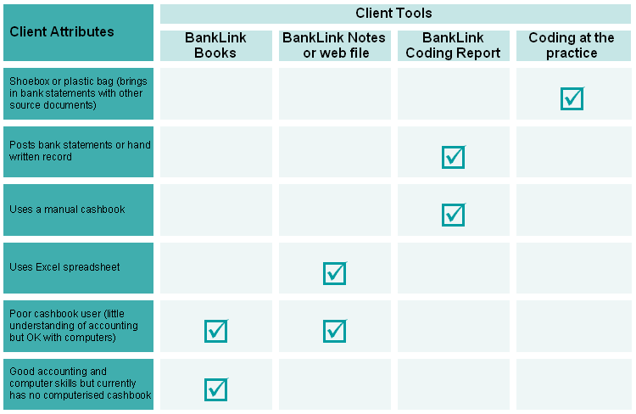
The options are shown below and explained in detail later in this section:
You do all the accounts with minor client input
You do all the coding - your client sees no BankLink information. You contact the client for any information you require by telephone, in writing or in person.
Your client completes the BankLink Coding Report
You e-mail, post or fax a BankLink Coding Report to your client. The client records information about each transaction on the report and sends it back so that you can enter the details into their client file in BankLink Practice.
Your client uses BankLink Notes
BankLink Notes is installed on your client’s computer. You e-mail your client a BankLink Notes file containing their uncoded data (or all transactions if you prefer). The client can add a combination of notes, Chart of Accounts codes and Payees (you decide which combination) to the transactions before e-mailing the file back to you. You import this information directly back into their client file in BankLink Practice.
Your client uses BankLink Books
BankLink Books is installed on your client’s computer. The client codes the data and can produce their own GST Returns, cash flow reports, budgets and graphs, if you want them to.
Whether you use BankLink Books, BankLink Notes or the BankLink Coding Report to communicate with your client, you can include your practice logo and contact details. This means that your client clearly sees your practice's involvement with the process.
You can use BankLink Practice’s Client Manager to monitor the status of each client file according to the BankLink client tool that they are using. For further information on Client Manager refer to the BankLink Practice Guide or call BankLink Support.

The BankLink Client Tools

Coding at the practice
You do all the coding - your client sees no BankLink information.
If you need to contact the client to confirm transaction details, you could do this by telephone, in writing, or in person.

Your client completes the BankLink Coding Report
BankLink Coding Reports can be sent to clients who either do not have access to a computer, or do not have sufficient computer skills to competently use either BankLink Notes or BankLink Books.
The BankLink Coding Report lists bank statement transactions for a given period (either uncoded or all transactions), in a format that allows your client to record descriptions and/or codes against individual items, along with an indication of whether they have a tax invoice, and the GST amount charged. Once completed by the client, this report is then returned to the practice where the information is entered into BankLink Practice.
The client completes the Coding Report using a combination of the following methods, depending on their ability:
- Allocating a Chart of Accounts code to a transaction from a list supplied by the practice (from BankLink Practice).
- Allocating a Payee Name or Payee Number to a transaction from a list supplied by the practice (created in BankLink Practice).
- Writing a description (Notes) of the transaction, for example - who it was to, and/or what it was for.
The practice chooses which combination of above methods their client can use, sending the Chart of Accounts and Payee list only to clients who will use them correctly.
The Coding Report can be e-mailed, faxed or posted to the client once the data has been received at the practice, either as part of a bulk run using Scheduled Reports for selected clients or directly from the client file. You can set up headers and footers for the Coding Report to include your practice logo, contact details as well as instructions for completing and returning the report.
Here’s an example of the BankLink Coding Report printed in cheque number order after it has been completed by the client:
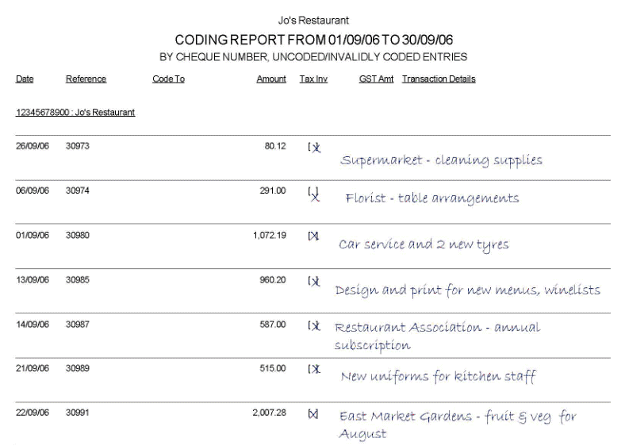
You can also include your practice logo, contact details and instructions for completion in the header and footer areas of the report. For detailed information on the BankLink Coding Report refer to the BankLink Practice Guide, (just press F1 when you're using BankLink Practice).

Your client uses BankLink Notes
Clients who have a computer with e-mail access use BankLink Notes when the functionality of BankLink Books is more than they require. BankLink Notes is a step up from the Coding Report and is very simple for your client to use. You send the BankLink Notes files to your clients as e-mail attachments which they can double click to open.
Here they view their bank statement transactions in a screen similar to the Code Entries screen in BankLink Practice. They type directly into the BankLink Notes file to add information to their transactions, before e-mailing the file back to the practice.
This is what the BankLink Notes screen looks like - you can add your own logo to the file, promoting brand awareness and raising your profile as a technology-savvy practice.
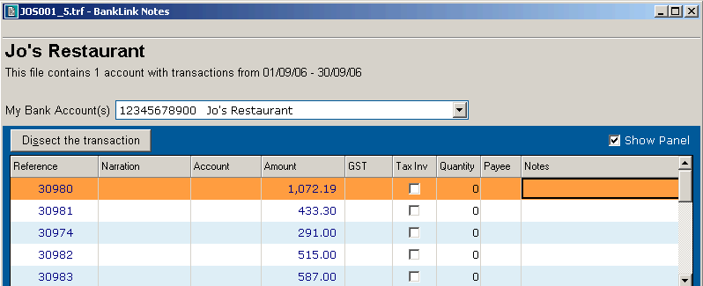
When your client returns the BankLink Notes you import it into their client file in BankLink Practice adding Notes, Chart of Accounts codes or Payees against each transaction. There is no need to manually enter anything they have written and you have a permanent record in BankLink Practice of what your client has told you.
Depending on their ability, your client can enter information into the BankLink Notes file using a combination of the following methods:
- Allocating a Chart of Accounts code to a transaction from the Chart of Accounts in the BankLink Notes file (a copy of the chart from BankLink Practice can be e-mailed as part of the BankLink Notes file).
- Allocating a Payee to a transaction from the list of Payees in the BankLink Notes file (the Payee List is created in BankLink Practice and can be e-mailed as part of the BankLink Notes file).
- Typing a description of the transaction, for example - who it was to, and/or what it was for, in the Notes column of the transaction.
The practice chooses which combination of above methods their client can use, sending the Chart of Accounts and Payee list only to clients who will use them correctly. All BankLink Notes clients can add Notes to the transactions.
You send the BankLink Notes file directly from BankLink Practice; either as part of the Scheduled Reports routine, along with your printed or e-mailed Coding Reports, or from each individual client file. You can set up the client file to include your practice logo, staff or general contact details including phone number and e-mail address, and a hyperlink to your practice website.
For detailed information on BankLink Notes, refer to Chapter 8 in the BankLink Practice Guide - press F1 in BankLink Practice.

Your client uses BankLink Books
BankLink Books suits clients who have a reasonable knowledge of both computers and accounting. As a BankLink practice you can install BankLink Books on any computer without having to purchase additional licences.
This means that you can install BankLink Books on your clients' computers and allow them to do their own coding. Anything that a general user in your office can do or see in a client file, your clients will be able to do or see.
You can set up the client file to include your practice logo, staff or general contact details including phone number and e-mail address, and a hyperlink to your practice website.
Detailed information on how BankLink Books works can be found in Chapter A2 - BankLink Books clients in the BankLink Practice Guide.
BankLink Books can operate in several different ways:
- Client downloads own data, codes & produces GST Return
This client is computer literate and competent with the application of accounting principles. They use BankLink Secure (internet) to download data directly from BankLink, code it and complete their own GST Return. The practice sees the file at year-end or at intervals throughout the year to review the work.
- Practice sends data, client codes & produces GST Return
This client is computer literate with an understanding of basic accounting principles, and can apply these to the information received. The practice sends the client their updated file on a regular basis via e-mail. The client codes the latest transactions and completes their own GST Return, but returns the file to the practice on a regular basis (e.g. monthly), so the accountant can check the work; the accountant has more control.
- Practice sends data, client codes, practice produces GST Return
This client requires some supervision to oversee their accounting work, but is still reasonably competent with computers and accounting principles. The practice sends the client their updated file on a regular basis via e-mail. The client codes the latest transactions and then returns the file on a regular basis, for example monthly, to the accountant to check the work and prepare the GST Return.

Access to data
There are two ways your client can receive the data:
- The client downloads their own data directly from BankLink using the BankLink download process (BankLink Secure). You recall the client’s file(s) only when you need to review them. They must have access to the Internet. There is a monthly charge to the practice of $7.80 (plus GST) per client file for this service. The client needs to complete a BankLink Secure Client Order Form to be able to download their data. This form is in the Implementing BankLink section of this Toolkit and can also be found on the BankLink Practice CD.
- Your practice receives the client’s data and then sends it to the client via e-mail. The file must be returned to the practice so new data can be sent to the client. You can transfer client files between practice and client at any time.
Your client can back up their file using BankLink Books. They are prompted to save the file to another location so that the files can be easily recovered.

Analysis coding
Analysis coding is a free service offered by the following banks - ANZ, ASB, BNZ, National Bank, Rabobank and Westpac, as well as the Loan Society and NBS.
This service allows the account holder to enter a code on each cheque and/or deposit book slip, which is then captured by the bank. The bank manually enters this code into the Analysis column of your statement.
The BankLink software then matches the number entered in the Analysis column with the codes in your Chart of Accounts or Payee List. When a match is found the code is copied from the Analysis column to the Account code column, automatically coding your cheques and deposits.
To take advantage of the analysis coding service you need to request analysis coded cheque and deposit books (where applicable) from your local branch. Analysis coded cheques and deposit slips are the same as standard cheque or deposit slips except for the blank boxes at the left-hand bottom corner. You can enter up to 6 digits in the boxes provided.
Examples of analysis coded cheque and deposit slips are shown below, and on the next page is a standard letter to request the specific cheque or deposit books needed from your bank.

Analysis coding - cheque and deposit slip
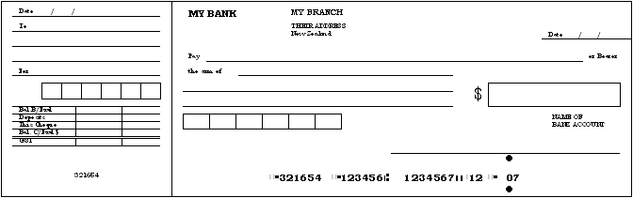
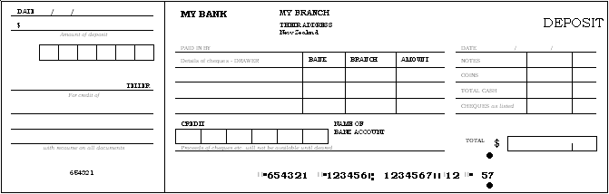

Analysis coding request letter
[Date]

[Name of Bank]
[Branch Name]
[Address Line 1]
[Address Line 2]

Attention: Customer Services

Dear Sir/Madam
Re: | [Account No. 1]
Re: | [Account No. 2]
Re: | [Account No. 3]
Please change the style of the cheque and deposit books for the above accounts to the analysis coded cheque and deposit books as indicated below.
ANZ | Cheque Book | 100 Forms |  | 028
 | Cheque Book | 100 Forms | Not Negotiable | 030
 | Cheque Book | 100 Forms | Not Transferable | 031
 | Cheque Book | 240 Forms |  | 057
 | Deposit Book | 50 Forms |  | 084
ASB | Cheque Book | 120 Forms |  | 544
 | Deposit Book | 50 Forms |  | 584
BNZ | Cheque Book | 50 Forms |  | 028
 | Cheque Book | 50 Forms | Not Negotiable | 030
 | Cheque Book | 100 Forms |  | 044
 | Cheque Book | 100 Forms | Not Negotiable | 046
 | Cheque Book | 200 Forms |  | 057
 | Cheque Book | 200 Forms | Not Negotiable | 059
 | Deposit Book | 50 Forms |  | 084
Loan Society | Cheque Book
 | Deposit Book
NBNZ | Cheque Book | 100 Forms |  | 28
 | Cheque Book | 100 Forms | Freeplan | F28
 | Deposit Book | 50 Forms |  | 84
 | Deposit Book | 50 Forms | Freeplan | F84
NBS | Cheque Book
 | Deposit Book
Rabobank | Cheque Book
Westpac | Cheque Book | 120 Forms |  | 44
 | Cheque Book | 120 Forms | Not Negotiable | 45
 | Cheque Book | 120 Forms | Not Transferable | 46
 | Deposit Book | 50 Forms |  | 84

[I/We] would appreciate if these books could be posted to [me/us] as soon as possible.

Yours faithfully

[Name of Account Signatory] [Name of Account Signatory]

Signing your clients up
In this section you'll find a variety of marketing tools which you can use to bring clients onto the BankLink service.
Included in this section:
- Ways to approach your clients
- Sample client letters
- Sample BankLink article for practice newsletters
- Sample client seminar PowerPoint presentation
- Sample advertisement
- Sample Third Party Authority Form
- Answers to your clients' frequently asked questions

Ways to approach your clients
Practices use a variety of ways to approach their clients in order to get them on to BankLink. Here are a few suggestions:

Create a BankLink ‘Show and Tell’ folder
This can be used during an annual review or any client meeting to show how the BankLink service works and what it can do for your clients. Adapt the Microsoft Word versions of the relevant sections, which are available on the BankLink Practice CD.
Items you might want to include in the folder are:
- What is BankLink? (use the BankLink for your Clients description from the What is BankLink? section)
- How BankLink works (use the picture from the What is BankLink? section)
- Benefits of BankLink (select from the Convenience for Clients benefits in the Benefits of BankLink section and include quotes from other clients)
- Value added services that can be offered (show the sample management reports layout from the Reports and Graphs section)
- Third Party Authority Form (include one at the back of the folder so the client can sign up immediately)
- BankLink’s privacy statement to allay any worries your client may have about security (from the What is BankLink? section)

Send out a direct mailer to clients
Select from one of our sample letters, or use sections, adding your own words to produce your letter. You may have one standard letter that you send to all clients or several letters depending on which BankLink client tool you recommend. You could also include a BankLink Books, BankLink Notes or BankLink Coding Report brochure and a pre-filled Third Party Authority form in the mail-out. Several brochures and a pack of authority forms are included in this Toolkit. Contact BankLink if you would like more, they are all supplied free of charge.

Host a Client Seminar
Use the client seminar PowerPoint template included on the BankLink Practice CD to create a presentation for your clients - thumbnails of the presentation are included later in this section. You may also want to use some of the information from the Show and Tell folder as handouts for your clients.

Sample Letters
If you decide to write to your clients about BankLink, the following sample letters may be useful: -
- A letter to include with a BankLink information pack
- A letter for clients to whom you will offer no choice about using the BankLink service
- A letter to introduce BankLink Practice as a new practice system
- A letter following a phone call to a client
- A letter to approach new business clients
There is also a master sample letter to which you can add a variety of opening paragraphs depending on the type of client:
- Clients who prefer to do no bookkeeping
- 'Shoebox' clients
- Manual cashbook clients
- Computerised cashbook clients
- Computerised accounting system clients
Finally, there is a real-world example of how a practice has used the samples to create its client letter.
All these letters are available as Microsoft Word documents on your BankLink Practice CD.

Letter with BankLink information pack
[Date]

[Client Name]
[Address Line 1]
[Address Line 2]
[Address Line 3]

Dear [Client Name]
An increasing number of financial institutions, including all the major banks, have an arrangement with BankLink, a service that is available to all businesses throughout the country.
This service enables the banks to supply a copy of your statement information directly to us, as your Accountants, in electronic form.
Please find enclosed:
- A BankLink Information Pack
- Third Party Authority form(s)
Please take the time to read the BankLink Information Pack. It explains in more detail the service that BankLink offers. Please give me a call if you have any queries or concerns.
All you need to do is complete and sign the attached Client Authority form(s) authorising us to collect copies of your bank statement transactions electronically. You will still get your own printed bank statement as usual.
Once signed, please return the authority form(s) to us in the enclosed envelope.
Here at [XYZ Partners], we look forward to delivering to you the tremendous benefits we know BankLink will provide.

Kind regards,

[Insert Name]
[Insert Title]

Letter for clients to whom you offer no choice
[Date]

[Client Name]
[Address Line 1]
[Address Line 2]
[Address Line 3]

Dear [Client Name],
To maintain our high level of customer service, while maintaining our fees at a reasonable level, this practice has investigated a number of methods and systems available on the market today and decided to implement a new system called BankLink. Using BankLink, we will be able to receive electronic copies of your bank statements which will integrate directly with our practice computer systems.
BankLink is used by over 3,000 accounting practices throughout Australia and New Zealand, and has been delivering this service for over 20 years. BankLink does not require or provide any transactional access to your accounts, and operates within the security requirements of all the major banks.
In order to use the BankLink service to obtain electronic copies of your transaction data, we need you to complete the enclosed BankLink Third Party Authority Form and return it to our offices as soon as possible.
Our practice will absorb the costs associated with the BankLink service as part of our commitment to providing clients with the best value accounting service available.
If you have any questions, or would like to know more about BankLink, please contact us directly on [phone number].

Kind regards,

[Insert Name]
[Insert Title]

Letter introducing BankLink as a new compulsory system in your practice
[Date]

[Client Name]
[Address Line 1]
[Address Line 2]
[Address Line 3]

Dear [Client Name]
We are currently implementing a new system in the practice that will enable us to work more efficiently and accurately, and serve our clients better.
Using the new system - BankLink - we will receive electronic copies of your bank statements directly from your bank, rather than having to ask you to send us hard copies.
We have enclosed a BankLink Third Party Authority form; please check the details, sign it and send it back to me, retaining the pink copy for your records.
You will continue to receive your bank statements as normal; our practice will simply receive an additional electronic copy of your statements. Please be assured that copies of your bank statements will be sent only to our practice. BankLink does not allow us to access your live accounts and it operates within the strict security requirements of all the major banks.
If you have any queries, please do not hesitate to contact me.

Kind regards,

[Insert Name]
[Insert Title]

Letter following a phone call to a client
[Date]

[Client Name]
[Address Line 1]
[Address Line 2]
[Address Line 3]

Dear [Client Name]
Further to our recent conversation regarding the benefits of the BankLink service, please find the enclosed Third Party Authority form(s) authorising us to collect your bank statement transactions electronically.
We look forward to receiving the signed authority form(s) by return mail, just place them in the envelope provided.
Please give me a call if you have any queries or concerns.
Here at [XYZ Partners], we look forward to delivering to you the tremendous benefits we know BankLink will provide.

Kind regards,

[Insert Name]
[Insert Title]

Letter to approach new business clients
[Date]

[Name]
[Address Line 1]
[Address Line 2]
[Address Line 3]

Dear [Client Name]

Do you wish doing your books was less taxing?
Would you like to start the new financial year free from the hassles of doing your accounts? It can be exasperating when you need to spend time making sure your business is running profitably; you have to spend hours with figures, cashbooks and GST calculations. Doing your accounts can be very time consuming – but help is at hand from [XYZ Partners].
[XYZ Partners] specialises in compliance accounting for small businesses just like yours. With our system, you can forget hunting for bank statements, spending hours writing out records, and the panic when it comes time for GST.
With your permission and under strict security measures, a copy of your bank or other financial statement information comes directly to us. The information goes directly into our general ledger and depending on how you want us to deal with your accounting, we can send you a report identifying which transactions we need more information on, either by mail, fax or e-mail. You fill in the blanks and return the report to us, it couldn't be simpler. We can also provide you with monthly financial reports to help you manage your business.
No computer skills are necessary and there is no specialised software to learn. We do your books for you – you just get on with running your business. All for as little as $xx dollars per month.
If you would like more information about [XYZ Partners], call me on [telephone number]

Kind regards,

[Insert Name]
[Insert Title]

Master sample letter
Adapt the paragraphs below as the core part of the letter and then add the relevant opening paragraph(s) from the following pages, depending on the type of client you are addressing. The text in brackets is optional, depending on client type.

We offer clients the option of using the BankLink service. This service provides a copy of statement information from banks and other sources directly into your ledger at the practice. This means that the practice receives financial information monthly, straight from the bank or other financial source.
With less data entry the chance of inaccuracies is reduced, saving time for both clients and practice when we are finalising accounts. Clients can choose how they want to provide additional data to us – either in written form, by e-mail or by using BankLink Books software themselves.
We receive all the statement information electronically and on a regular basis, so we can supply you with regular financial reports if you wish. It also means no more hunting for missing statements!
We can use the information to (produce regular reports and) complete your GST Return. You will continue to get a statement from your bank (and of course you can still use your software for debtors and creditors or stock/inventory).
There is a small charge for using the BankLink service, but this is likely to be far outweighed by
the time you will save that would have been spent entering information into your accounting software.
OR
the cost savings to you on our time which would have been spent manually sorting the information you give to us.
OR
the cost to you of our time spent checking information and correcting any errors which can easily be made with a manual cashbook.
I enclose a BankLink brochure, giving more detail about this service (along with an authority form for you to complete and return to us). Please give me a call if you would like more information about BankLink.

For the letter to a ‘shoebox’ client
Dear
If you are spending more time than you would like dealing with accounting information, we can help at [XYZ Partners].

For the letter to a manual cashbook user
Dear
If you are spending more time than you would like dealing with accounting information, we can help at [XYZ Partners]. Many of our clients employ methods of bookkeeping that are more time consuming than is necessary, or record transactions that would be more easily dealt with in another way.

For the letter to a computerised cashbook client
Dear
We have been approached by a number of clients who are concerned about the possibility of errors in their GST reporting. For some, these errors have been compounded by use of an accounting software package that, for a variety of reasons, is unsuited to their needs.
Some people find they are spending more time than they would like, transferring statement information into their accounting software, or find that they spend longer on their computer than running their business. Others are using packages that are too complex for their business requirements and are paying for software upgrades they do not need.
If you think you fall into any of these categories, we suggest you consider using a product we offer clients, called BankLink Books.

For the letter to a computerised accounting system user
Dear
At [XYZ Partners] we recognise that some clients are using an accounting software package which for a variety of reasons is unsuited to their needs.
You may find that you are spending more time than you would like, transferring statement information into your accounting software. You may also have found that you spend longer on your computer than running your business. You could be using a package that is too complex for your business requirements, paying for software upgrades that you do not need.
Whatever the reason, we suggest that you use a product called BankLink Books, used by many of our clients.

Sample BankLink article for practice newsletters

DO YOU WISH DOING YOUR ACCOUNTS WAS LESS TAXING? It could be if you use a service we offer at (XYZ Partners) called BankLink.
The BankLink Service delivers a secure, electronic copy of your bank statement directly from the bank to your accountant. It means that all your financial data comes directly to us. No more storing up cheque book stubs, searching for missing bank statements, or providing us with your reconciliation on disk.
From this information, we can code the transactions, or quickly identify where we need more information from you. We can also provide quick, accurate information for GST returns.
Using BankLink saves you time that is better spent running your business.
More information – when you need it
As the BankLink service allows us to work with your accounts on a regular basis, we can keep track of your business performance and provide you with improved business information.
Is BankLink secure?
An electronic copy of your bank statement is sent to us under strict security measures. The file is encrypted and cannot be accessed by anyone other than us. This is considerably more secure than sending bank statements by post! Your relationship with your bank does not change. You still receive your printed bank statement from your bank as usual.
Who uses BankLink?
Over 3,000 accountancy practices in Australia and New Zealand use BankLink.
All major banks are supplying data through BankLink and there is increasing penetration into other financial institutions with over 100 banks, building societies, credit cards and rural suppliers available.
Interested? Call us now on (insert practice number) and we can give you more details. It could be the best New Year's resolution you make!

Sample PowerPoint presentation for a client seminar
You can use this presentation to inform your clients about the BankLink service. It's a Microsoft PowerPoint file and the first two slides are shown below. To view the rest please review the file included on your BankLink CD.

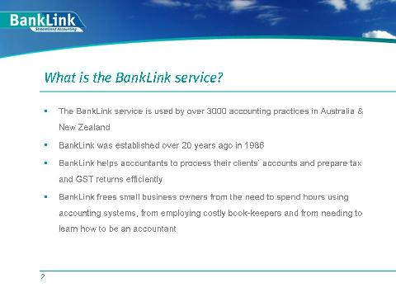

Sample advertisement

 | Want your accounts to be less taxing?  Free yourself from hours spent writing out records or sitting at the computer doing the books. At [XYZ Partners] we use a service called BankLink to complete our clients’ book work quickly and efficiently. We don’t need your bank statements (not even the missing ones!) or cheque butts.  Let us free up your time – ask us about BankLink and you can spend more time on running your business, or going to the beach!  XYZ Partners logo and contact details

Sample Third Party Authority Form
Here's an example of a completed Third Party Authority Form. There's a .pdf version on the BankLink Practice CD if you would like to use it to show clients how to fill out their authority forms.
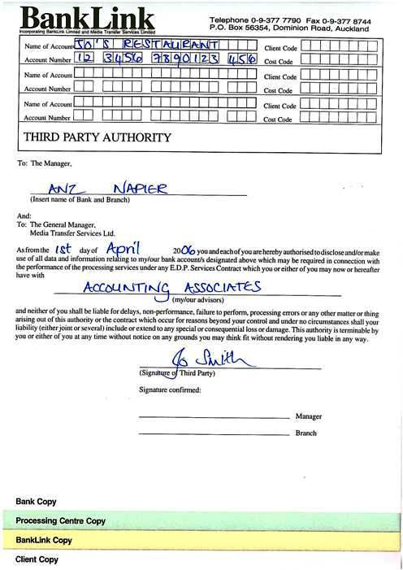

Frequently Asked Questions
To help you explain the BankLink service to clients here are the answers to questions practices tell us are most frequently asked. These questions can also be used in presentations to clients or in your practice’s Show and Tell folders for clients.

Who uses BankLink?
Over 3,000 accountants in Australia and New Zealand use BankLink to process more than 200,000 bank accounts just like yours.

What are the advantages of BankLink?
Refer to the Convenience for Clients points in the Benefits of BankLink section to discover many of the advantages of BankLink for your clients.

Is my bank on the BankLink service?
All major banks and many other financial institutions provide data to BankLink in New Zealand.
You can view the complete list on the BankLink website (www.banklink.co.nz).

Can you access my bank account?
Absolutely not, we are simply receiving an electronic copy of your banking transactions.

Will I still receive my bank statement?
The relationship between you and your bank does not change. You will still receive your printed statement from your bank as usual.

What happens if I change my bank account(s) during the year?
You’ll need to let us know at least a few weeks before this happens. We’ll simply send you a fresh Third Party Authority form for your new bank. You need to complete and return the authority form to us so that we can start receiving data from the moment you open the new account.

Is the information accurate?
The accuracy of the information is the same as your bank statement - the statement information is sent directly from your bank.

Is the BankLink service secure?
The transaction data is supplied in encrypted form and cannot be accessed by anyone other that the intended recipient. This is considerably more secure than sending bank statements by post! You will need to authorise your accountant to obtain a copy of your details. BankLink’s Privacy Statement details the security in place at BankLink.

How do we get BankLink right now?
- You need to complete and sign a BankLink Third Party Authority form.
- We send this to BankLink, they complete the set-up process.
- Where necessary, we provide you with training.

What do we need to do once we are on BankLink?
Refer to the description of the various client tools
- Using BankLink Books
Use BankLink Books to code your statements and produce your GST Return.
- Using BankLink Notes
Simply reply to your accountants’ monthly email with the BankLink Notes file attached.
- Using the BankLink Coding Report
Complete the report! Relax and let your accountant do the work. We may ask for additional information.
- In-house
We will contact you when we need any information from you.

Can I do my own coding?
For clients who have their own computers, this may be possible. (Refer to the description of levels in the Ways of Using BankLink section to see how). Clients who are interested in this feature need to be prepared to invest some time and money in structured training.

Can you backdate transactions in BankLink?
Yes, backdating transactions can be done manually, using a feature called Historical Data Entry. Although manually entering a few weeks’ of backdated transactions is not difficult to do, it is always more efficient to get BankLink loaded by the beginning of the new financial year or month, or from the start with a new bank account. Some institutions can provide backdated data. This, however, is the exception. The list of financial institutions on the BankLink website indicates which institutions provide historical data.

What reports are available from BankLink?
Refer to the Reports and graphs section where you will find a list of all reports available from BankLink as well as sample reports and suggested report structures to show to your clients.

Who provides product support?
We, the practice, provide all support. Simply call us if you have any questions.

What will it cost me?
There is no additional charge from the client’s bank for the BankLink service. All charges are passed from BankLink to the accountant. Here are some samples of client charging options used by BankLink practices:
Either:
The monthly charges for BankLink will be absorbed by the practice, recovered from timesaving.
Or:
There is a monthly fee of $$$.$$. Practices often calculate this by estimating the number of transactions likely during the year, multiplying that with the BankLink charges per transaction, adding a practice mark-up and dividing this by the twelve months.
Or:
The practice will pass on the BankLink charges.
Refer to the Costs section to view BankLink charges to the practice and some examples of how practices charge their clients for BankLink.
Client training may be required and should be charged at your normal hourly rate. The cost of the training will vary from client to client according to their type of business and specific needs. Estimates of training costs should be provided to clients in advance.
BankLink does not charge for software upgrades.

Will our accounting fees go down?
This is unlikely, however you will receive added value in the form of GST compliance and business improvement services.

Reports and graphs
As well as producing GST Returns almost as a by-product of the coding process, you can use BankLink Practice to provide your clients with a great range of financial reports and graphs. The reports are quick and easy to produce and can be tailored to your clients’ requirements.
Reports include: -
- Cash Flow
- Profit and Loss
- Trial Balance
- Balance Sheet
- Ledger Report
- Bank Reconciliation
- GST Reports
- Spending by Payee
- Exception Reports
as well as various listings.
The report headers and footers on the Cash Flow, Profit and Loss, and Balance Sheet reports can be customised to display your practice logo and contact details, raising awareness of your brand. The reports can be saved as PDF files which are ideal for emailing to clients.
To find out how to produce all the reports and graphs, see the following Chapters in the BankLink Practice Guide: -
- Chapter 12: Setting up Reporting
- Chapter 13: Producing Reports
- Chapter 14: Producing Graphs
You may want to show some of these reports to your clients as an example of the information you can provide to them when they sign up to the BankLink service. Sample reports and graphs are available on the BankLink Practice CD as PDF documents.
There's also an example of how one practice has bundled client reports into a complete financial reporting package by inserting cover sheets between each report - the example shows the first two cover sheets. All the sheets are available as a Microsoft Word document on your BankLink CD.

Example Financial Report Package
Practices often put together a pack for their clients, containing reports such as the Cash Flow, Profit and Loss and GST Audit Trail, along with the one-page graph summary. The cover sheets below are available for you to adapt as a Microsoft Word document on your BankLink Practice CD.

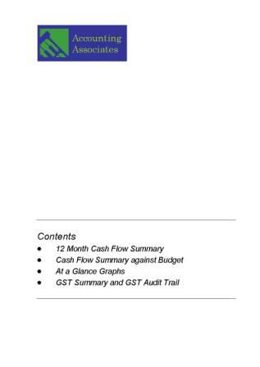

Graph – One Page Summary
Graphs allow you to show monthly figures in a form that is meaningful to both the practice and your client. Graphs include all coded cash transactions as well as cash journals. They tell you, at a glance, important facts about your client’s business.
There are four graphs that can be produced from BankLink Practice. The example shown here is a summary of all four: -
- Sales
- Investments
- Trading Results
- Bank Balance
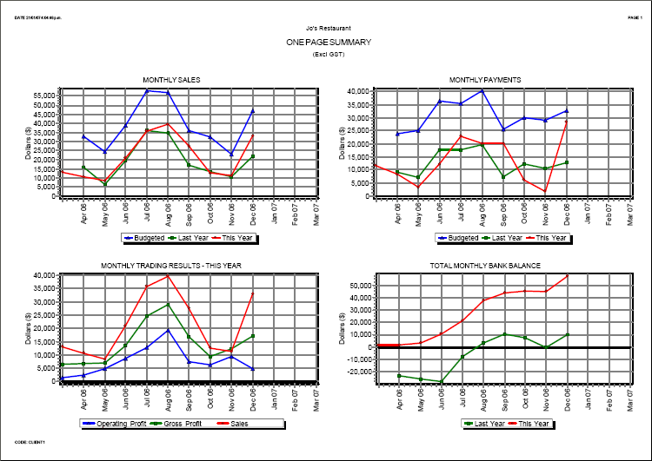
The graphs can be saved as PDF files which are ideal for emailing to clients.

Administration
This section contains templates for standard forms, letters and faxes to help you with the administration of BankLink.
When you introduce the BankLink service to your practice you need to set up some practice systems and procedures.
One of the first things you should do is to appoint a BankLink Administrator to create and maintain a BankLink Administration file. This file is where you keep records such as the office copies of the Third Party Authority Forms, correspondence with BankLink, download reports, client checklist forms, and BankLink invoices and statements. And that’s the end of the paperwork.
Included in this section:
- Sample administration forms
- Add Account Form
- Financial Institution Request Form
- BankLink Secure Client Order Form
- Software Kit Order Form
- Marketing Materials Order Form
- Glossary of BankLink terms
Using the forms on the following pages will streamline your communications with BankLink and make your use of the service more effective. All the forms are available on the BankLink Practice CD.

Add Account Form

[Date]

BankLink Ltd
P O Box 56 354
AUCKLAND

Attention: Client Services

Dear Sir/Madam

Re: Bank accounts to add
Our practice code is [Insert BankLink Practice Code].

Please find enclosed BankLink Third Party Authority forms as follows: -

Client | Bank Account Number

Please call us immediately if you have any queries concerning the enclosed authorities.
Yours faithfully

[Contact Name]
[Title]

Financial Institution Request Form

Please complete and fax to 09 377 8744

Attention: Product Manager
Practice
Practice Code
Contact
Date
Please indicate the name of the institution, the account type and the number of accounts you would load if this data was available.
Financial Institution | Account type e.g. Credit Card, Loan, etc. | Number you would load

BankLink Secure Client Order Form
Please register the following client as a BankLink Secure client so that they can retrieve their transaction data via BankLink Secure. I/We acknowledge that a monthly charge will be made to us for this service.
Client Name
Client Contact
Client Email
Initial Password*
* Please use a mixture of alpha and numeric characters. Passwords are case sensitive, so 'PASSWORD' and 'Password' are treated differently. The first time your client uses BankLink Secure they will be prompted to enter their password.
Bank Account Number** | Bank Account Name
**Multiple bank accounts can be attached to a client file. However, a separate download must be performed if your client has more than one client file. A separate form is required for each client file.
Transaction start date (date of first transaction): ________________________________
To register a client's bank account(s), complete all the details and sign the form before faxing it to BankLink. Please make sure you print this form on your practice letterhead.
Please allow two weeks for this application to be processed. Once the form has been processed, a BankLink Consultant will contact you to advise your client's BankLink Secure Code and Pin.
When data is ready to be downloaded, your client will be advised by email at the address you provided above.
Practice Name: |  | Practice Code:
Contact Name: |  | Date:
Signature:

Fax to BankLink Support: 09 377 8744
Office Use Only:
Client Services Processed | BankLink Secure Code | PIN | BankLink Consultant | Practice Advised

Software Kit Order Form
Use this form to place an order for BankLink Books, BankLink Notes or BankLink InvoicePlus Kits. Each Kit includes a copy of the latest software on CD, plus installation instructions, enclosed in a plastic case ready to provide to your client.

Prices
• One Kit - $20 + GST
• Two or more - $15 + GST each
• Postage, packaging and handling are included
_________________________________________________________________________

Practice Details
Complete your details below.
Practice Name
Practice Code
Order placed by: | PLEASE PRINT
Signature

Order Details
Enter the number of Kits you would like to order in the section below.

Kits | Number
BankLink Books
BankLink Notes
BankLink InvoicePlus
Order Total

Your practice will be invoiced for the Kits despatched.

Complete this form and fax to Client Services

at BankLink on 0800 377 8744

Marketing Materials Order Form
Use this form to place an order for the BankLink marketing materials that will help you to sell the BankLink service to your clients. The materials are free and include all our brochures, authority forms and quick reference cards.
_________________________________________________________________________

Practice Details
Complete your details below.
Practice Name
Practice Code
Order placed by: | PLEASE PRINT
Signature

Order Details
Please enter the number of each of the items you would like to order in the section below.
Brochures | Number
BankLink Books
BankLink Notes
BankLink Coding Report
BankLink InvoicePlus
Authority Forms
Packet of 25 forms
Other Materials
Quick Reference Cards

Complete this form and fax to Client Services

at BankLink on 09 377 8744

Glossary of BankLink terms
The terms listed below have meanings specific to BankLink: -

Bank accounts
Clients (see below) have bank accounts that contain the client’s transactions. You code the transactions by assigning account codes from the client’s chart of accounts to each transaction, coding it as Sales, Expenses, etc. Each bank account needs to be attached to the relevant client within BankLink.
Usually, the BankLink Administrator creates clients and attaches bank accounts, so unless you are the Administrator, all the set up work should be done by the time you come to work on client transactions. However, some client information can be maintained by all users.

BankLink Books
BankLink Books suits clients who have a reasonable knowledge of both computers and accounting. The software is free and you can supply it to as many of your clients as you wish to. You install BankLink Books on your clients' computers and allow them to do their own coding. Anything that a general user in your office can do or see in a client file, your clients will be able to do or see.

BankLink Notes
BankLink Notes is a separate computer application that allows your clients to record information about their bank statement transactions, using their computer and an electronic version of the paper Coding Report (see below). The software is free and you can supply it to as many of your clients as you wish to.
BankLink Notes effectively provides a more automated and controlled way to obtain information from your clients on their bank statement transactions, where you specify their level of involvement in the accounting process.

BankLink Secure
BankLink Secure is the internet service for downloading data. When you receive a notification e-mail or fax from us that your data is ready, you initiate the process from within BankLink Practice - data is encrypted and transferred across a secure connection.
Your clients who use BankLink Books can use this process, or receive their data via your practice.

Clients
Clients in BankLink are your practice’s clients who are signed up to use the BankLink service. Each client must be set up in BankLink Practice.

Coding
The process of assigning the client’s chart of accounts codes to their bank account transactions is called coding. Using BankLink Practice you can code entries directly in the Code Entries Screen – if the code is not in the client’s chart of accounts, BankLink Practice colours it red as a warning. Transaction entries can be split (dissected) between more than one account, based on amounts and/or percentages.
BankLink Practice also has powerful facilities for automatic coding of transactions (see Memorisations).
Once you have coded all the transactions you can:
- Transfer them to your main accounting system
- Produce a GST Return
- Produce a variety of reports and graphs

Coding Report
You can use BankLink’s coding report to list transactions for which you require further information and send them directly to your clients. The coding report lists the transactions with plenty of space for the client to provide details about each one. The bank account number appears at the top of the transactions on each page of the coding report - this means that if your client has more than one bank account, they always know which account they're working with.

Downloading
Once a month (or week), you receive data from BankLink. This consists of all the transactions for the client bank accounts you have signed on to the service. BankLink receives the data from the financial institutions, and passes it on to you.
Practices receive their data using a secure connection to the BankLink Secure service.
This process is known as downloading and is performed by the BankLink Administrator.

Interfacing to your accounting system
In order for you to code transactions correctly, BankLink Practice needs to know about your clients’ charts of accounts.
BankLink Practice can interface directly with most of the accounting systems practices use to manage their clients’ accounts. The principle advantage of this is that BankLink can read client chart of account information directly and copy it into BankLink Practice.
BankLink Practice interfaces to most popular client accounting packages. If you are not sure if BankLink Practice interfaces with your accounting system, contact BankLink Support or visit the BankLink website for a current list of supported accounting systems.

Index
A
Accuracy of the information 44
Add Account Form 51
Administration of BankLink clients 51
Administrator 21
Adobe® Acrobat Reader 23
Advertisement 42
Analysis coding 31
Approaching clients 35
Article for Newsletters 40
Authority Form 43
B
BankLink Books 30, 54
BankLink InvoicePlus 54
BankLink Notes 29, 54
BankLink Secure 53, 56
BankLink Secure Client Order Form 53
Benefits 7
C
CAF 43
Case Studies 10
Charges 13
Client Checklist 17
Client Seminar 35, 41
Client stream 19
Code Entries Screen 56
Coding Report 28
E
Example financial report package 47
F
Frequently Asked Questions 44
G
Getting Started 17
Graphs 49
GST 3, 7, 25
Guide 23
H
Help 23
L
Latest Documentation 23
Level Four 28
Level One 30
Level Three 28
Level Two 29
Levels 27
M
Marketing Materials 55
Memorisations 56
O
One-page summary 49
Order Form 55
P
Payees 56
R
Reconciliations 7
Review Plan 23
S
Sample letters 36
Sample PowerPoint presentation 41
Software Kit 54
Support 23
T
Technology Checklist 17
TPA 43
Training 23
Tutorial 23
U
Unpresented items 56
V
Value added reports 47
W
Website 23
Weekly Data 13

